- How to activate the Data Analysis Toolpak (in Excel 2013)

File -> Options -> Add-Ins

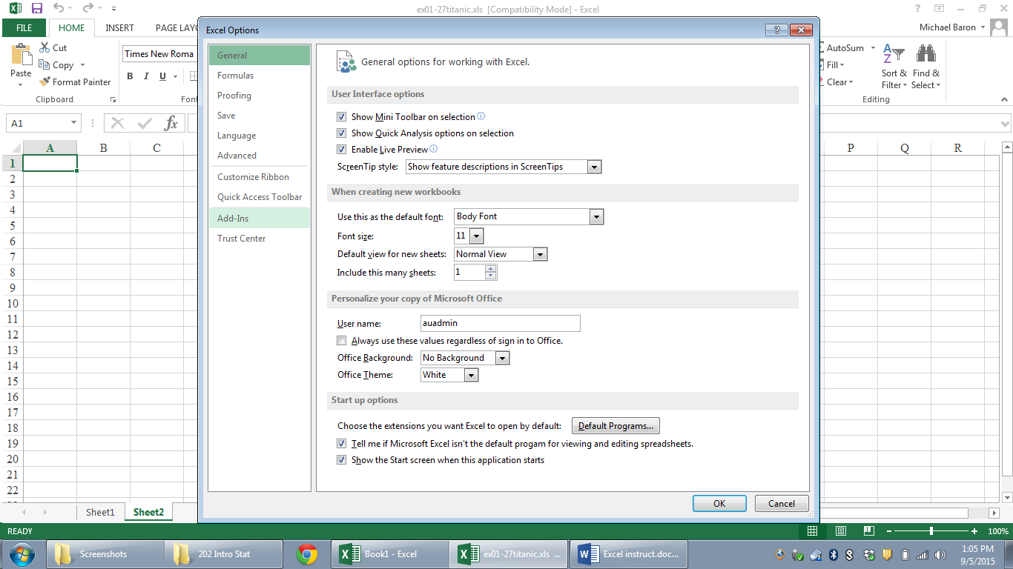

Click “Add-Ins”

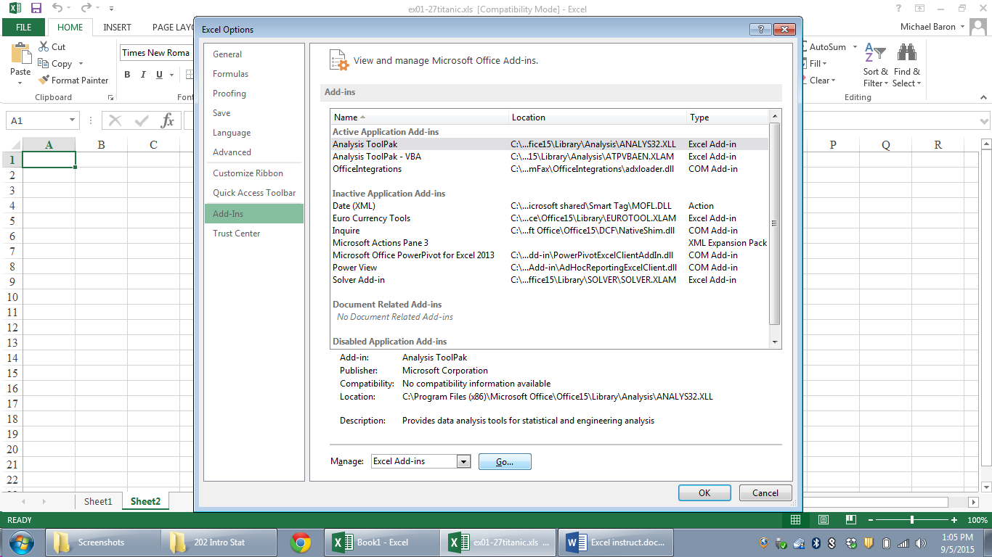

Choose “Analysis ToolPak” and click “Go…”

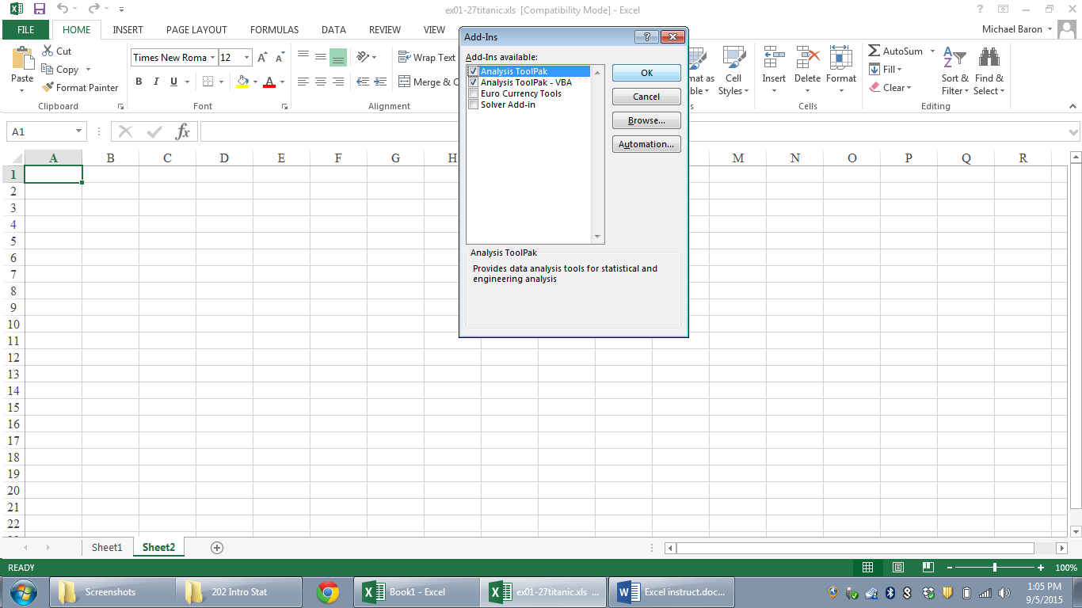

Check the box “Analysis ToolPak” and press OK.

Now you have the ToolPak under “Data” tab, on the right:

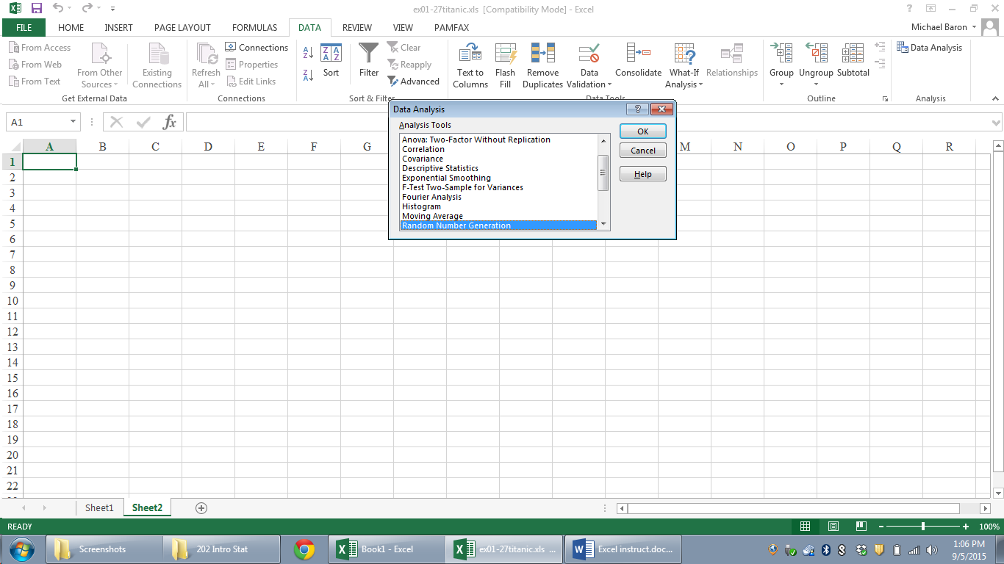

In Excel 2016 on Mac, “Add-Ins” is under the “Tools” tab.

